Part 2:Hosting A static website on Aws S3

Step 1: **:** Log in to AWS Academy and start the Learner Lab.

Step 2: Search for the S3 service in the AWS management console

Step 3: Create a new S3 bucket.

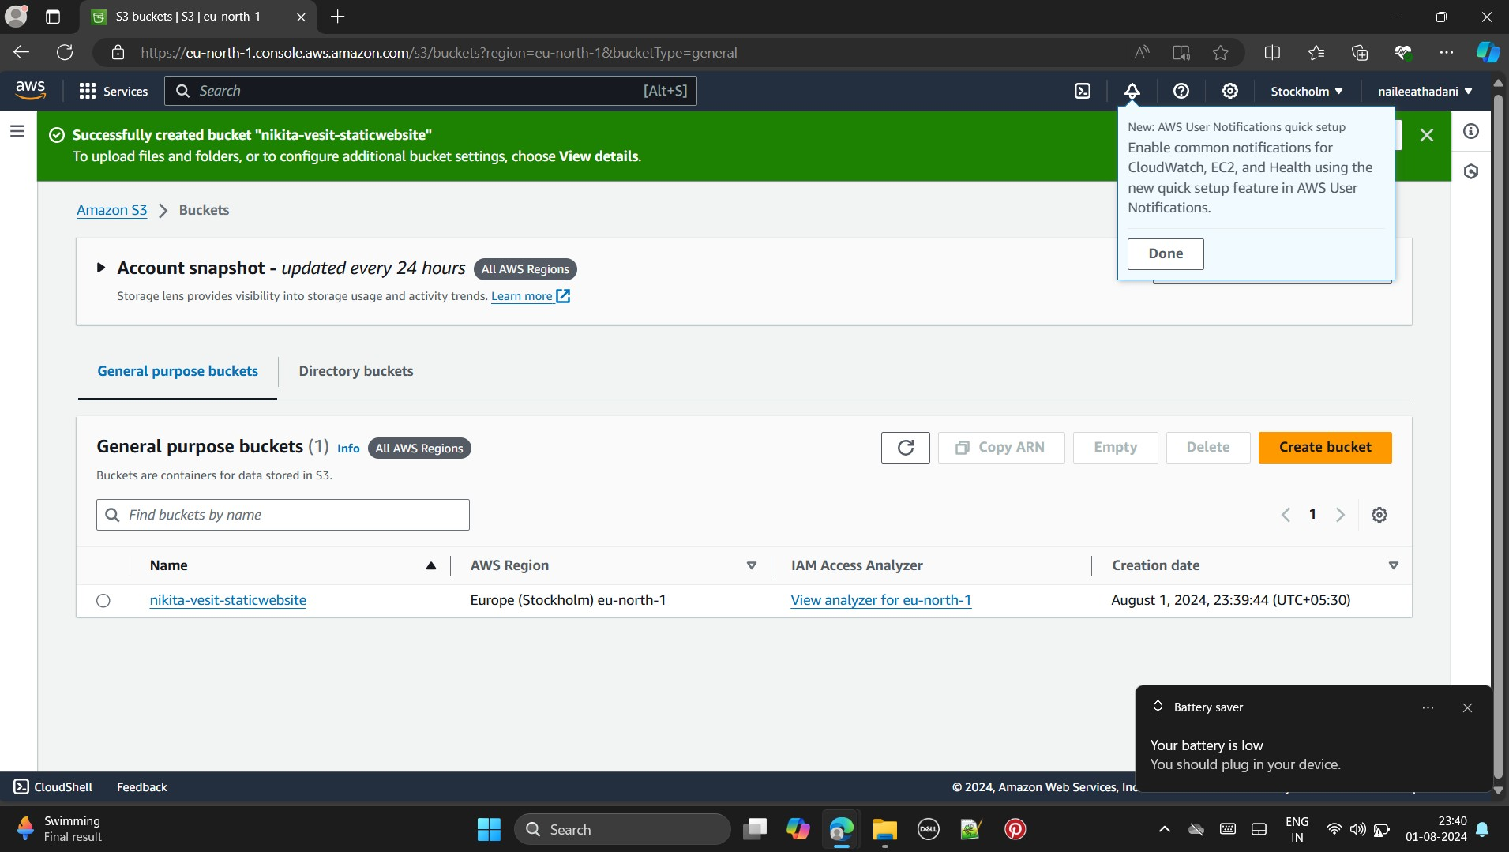

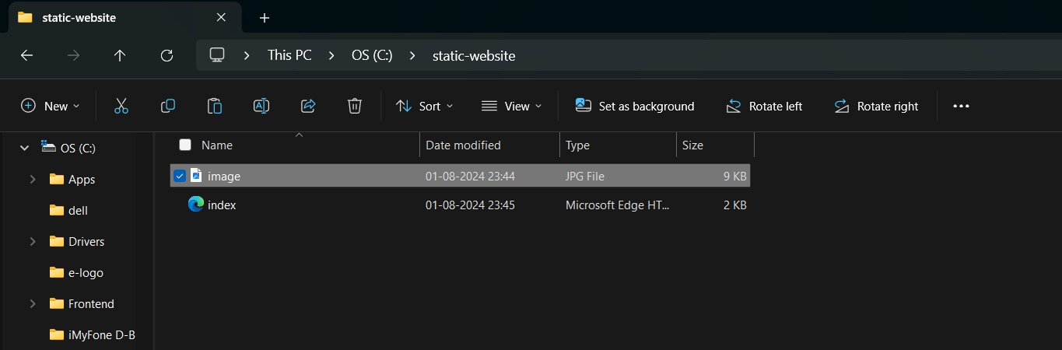Step 4:Add content to the bucket

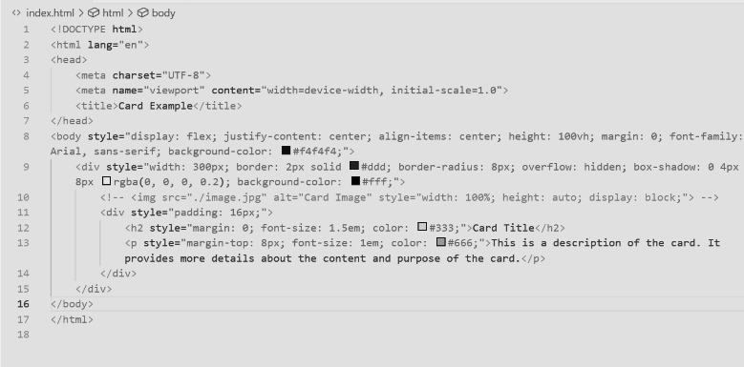

Step 5 Fill in the required details and name your bucket. Use the default settings, but make sure to uncheck the ‘Block all public access’ option.

Step 6: After completing the setup, click ‘Create Bucket.’

Step 7: Open the newly created bucket, go to the Objects tab, and click ‘Upload.’ Add your files and then click ‘Upload Files.’

Step 8: Navigate to the Properties tab and find the ‘Static website hosting’ section.

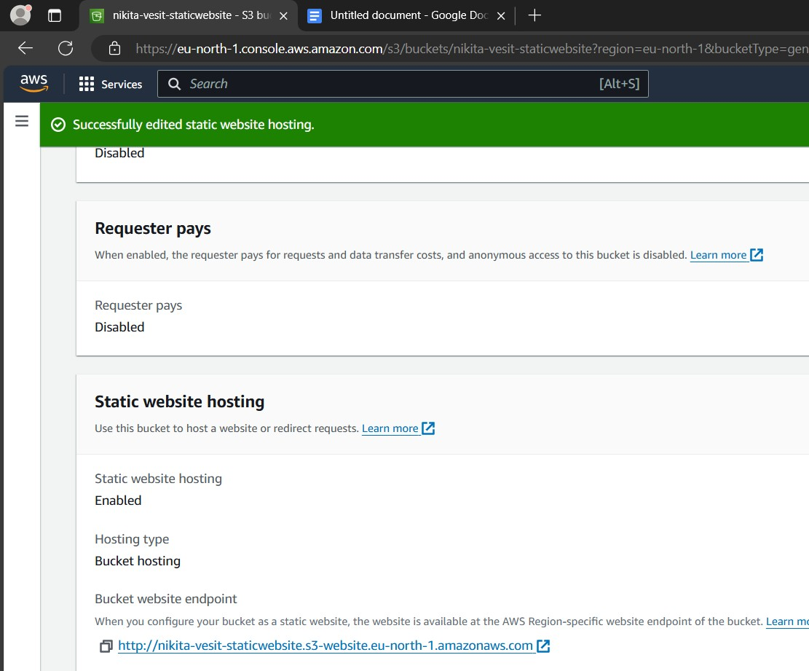

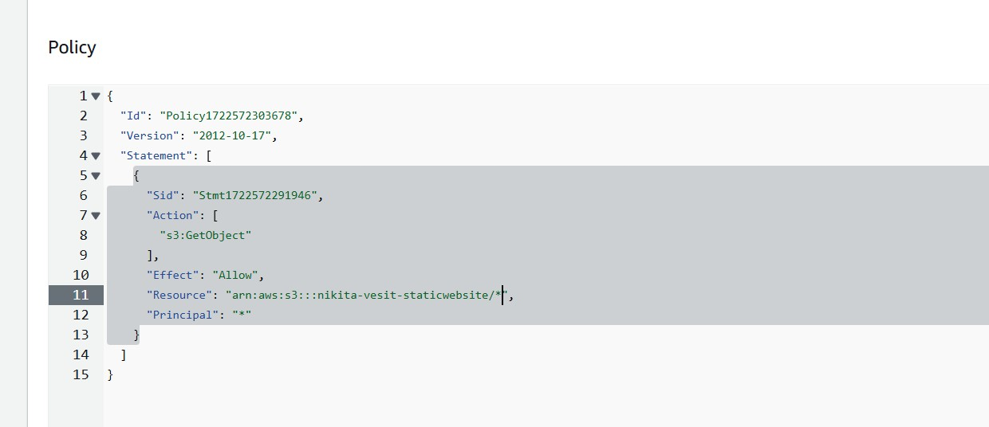Step 9: Go to the Permissions tab and access the ‘Bucket policy’ section.

Step 10**:** Once the policy is updated, a link to your static website will be available.

